**USER GUIDE USER GUIDE USER GUIDE USER GUIDE USER GUIDE USER GUIDE USER GUIDE USER GUIDE USER GUIDE USER GUIDE USER GUIDE USER GUIDE USER GUIDE USER GUIDE USER GUIDE USER GUIDE USER GUIDE USER GUIDE USER GUIDE USER GUIDE USER GUIDE USER GUIDE USER GUIDE USER GUIDE USER GUIDE USER GUIDE USER GUIDE USER GUIDE USER GUIDE USER GUIDE USER GUIDE USER GUIDE USER GUIDE USER GUIDE USER GUIDE USER GUIDE USER GUIDE USER GUIDE USER GUIDE USER GUIDE USER GUIDE USER GUIDE USER GUIDE USER GUIDE USER GUIDE USER GUIDE USER GUIDE USER GUIDE USER GUIDE USER GUIDE USER GUIDE USER GUIDE**



Content……..2

Installation…..3

Getting Started

Enter the Password….4

Navigation…..5

Worksheets…..5

Data Input

Data Entry…..9

Data Output

Viewing charts …..10

Miscellaneous

Troubleshooting…..11

Without password…..11

With password…..11

Exiting workbook…..11

Deleting Workbook…..12

Installation

|  |  |
| --- | --- |
| Computer and processor | 1 GHz or faster x86 or 64-bit processor with SSE2 instruction set. |
| Memory | 1 GB RAM (32-bit); 2 GB RAM (64-bit). |
| Hard disk | 3.0 GB available disk space. |
| Display | Graphics hardware acceleration requires a DirectX10 graphics card and 1366 x 768 resolutions. |
| Operating system | Windows 7, Windows 8, Windows Server 2008 R2, or Windows Server 2012. |
| Browser | Microsoft Internet Explorer 8, 9, or 10; Mozilla Firefox 10.x or a later version; Apple Safari 5; or Google Chrome 17.x. |
| Net version | 3.5, 4.0, or 4.5. |
| Multi-touch | A touch-enabled device is required to use any multi-touch functionality. However, all features and functionality are always available by using a keyboard, mouse, or other standard or accessible input device. Note that new touch features are optimized for use with Windows 8. |
| Internet | * Excel 2010 Internet functionality requires an Internet connection and either Internet Explorer 8 or Internet Explorer 9. * Instant Search functionality requires Windows Search 4.0. |
| Power Pivot | To use Power Pivot, you must have .NET 3.5 or .NET 4.0 and at least 2GB of RAM. |
| Power View add-in | To use with the Power View add-in, you must have Silverlight 5.0 installed and at least 2GB of RAM. |

Getting Started   
Enter the Password

When opening the wordbook it will ask for the password. It will open without a password however the “Staff Date” can’t be access.

Staff Login – Cross the user form or press login and click on because the staff doesn’t need a password  
Manager Login – “Joes” – If it’s a mistake you will be able to renter the password again

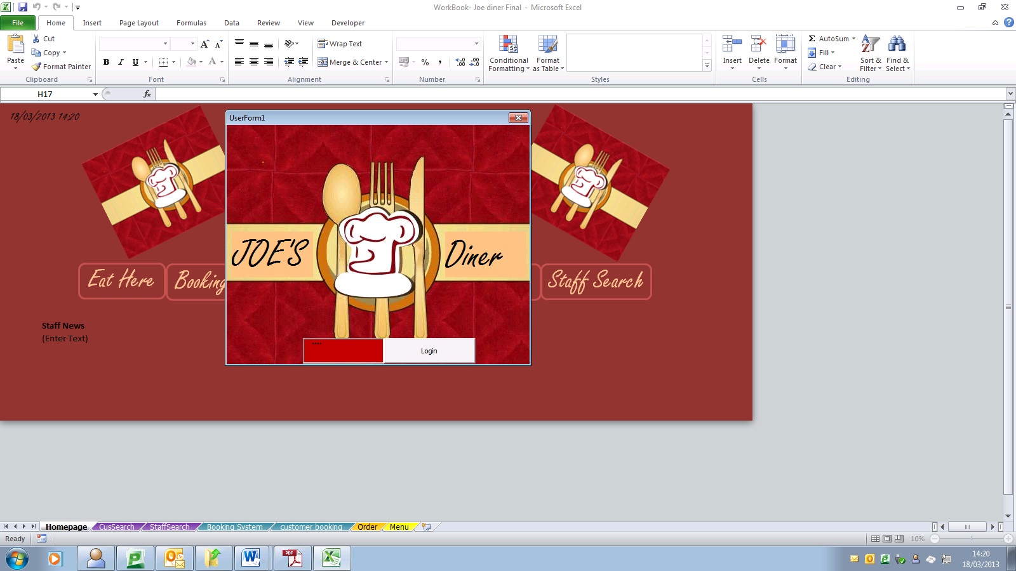

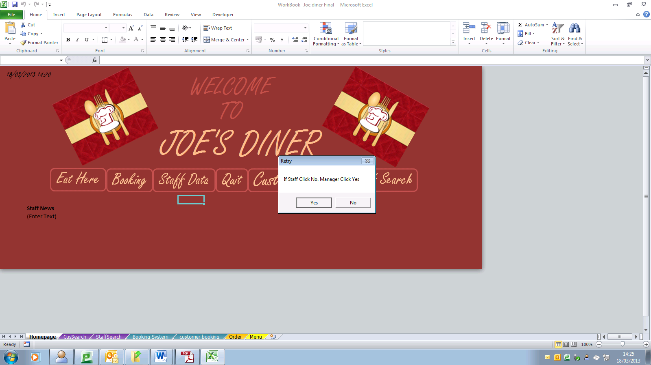

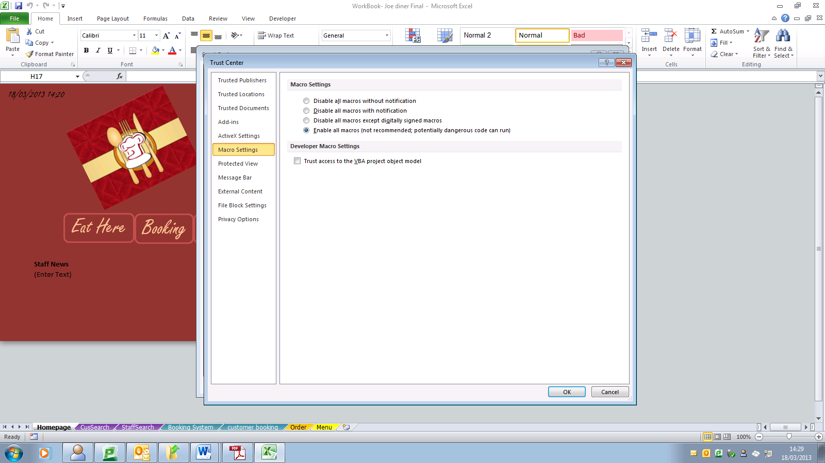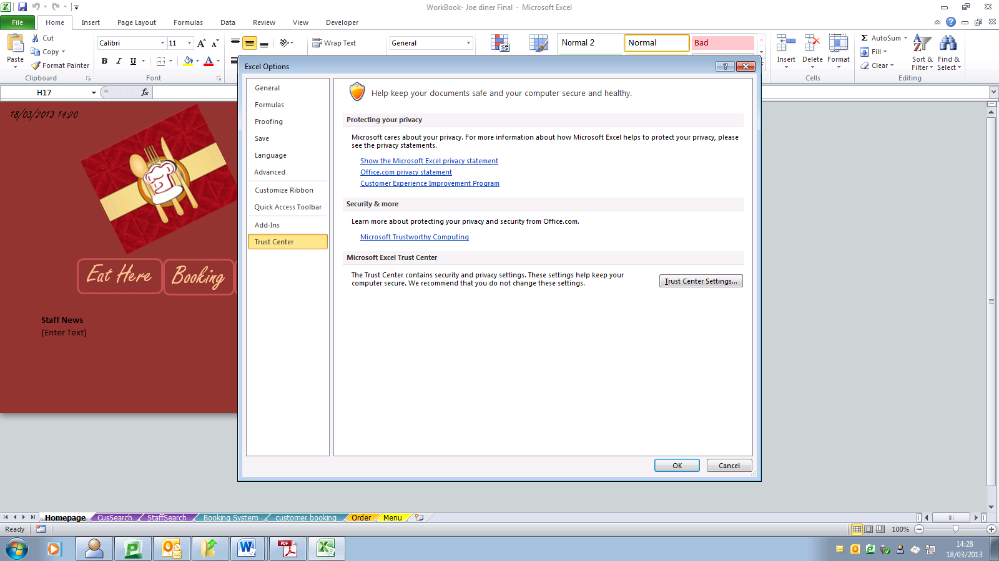

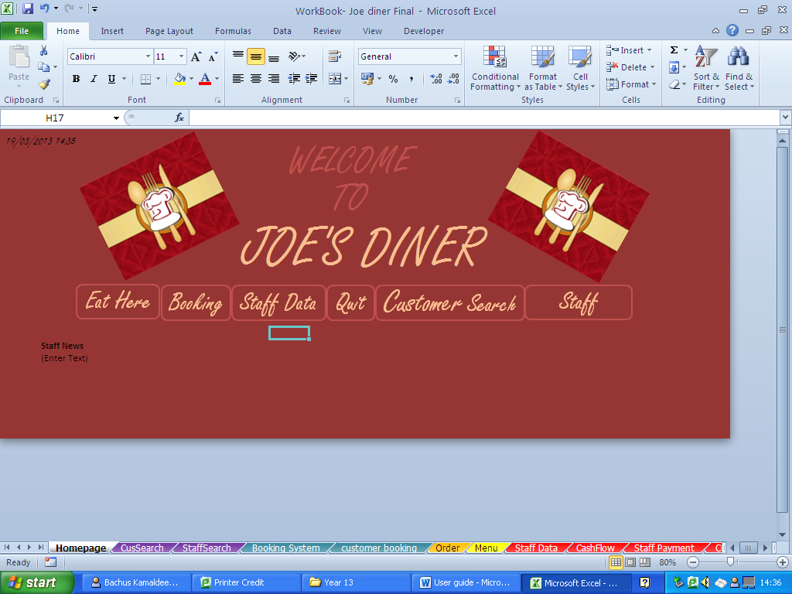

To unlock the sheets the password is the same as the Client login which is. “Joes”

Unlock Sheets:

Navigation

There is an easy navigation all around the work book. The buttons on the main menu are:

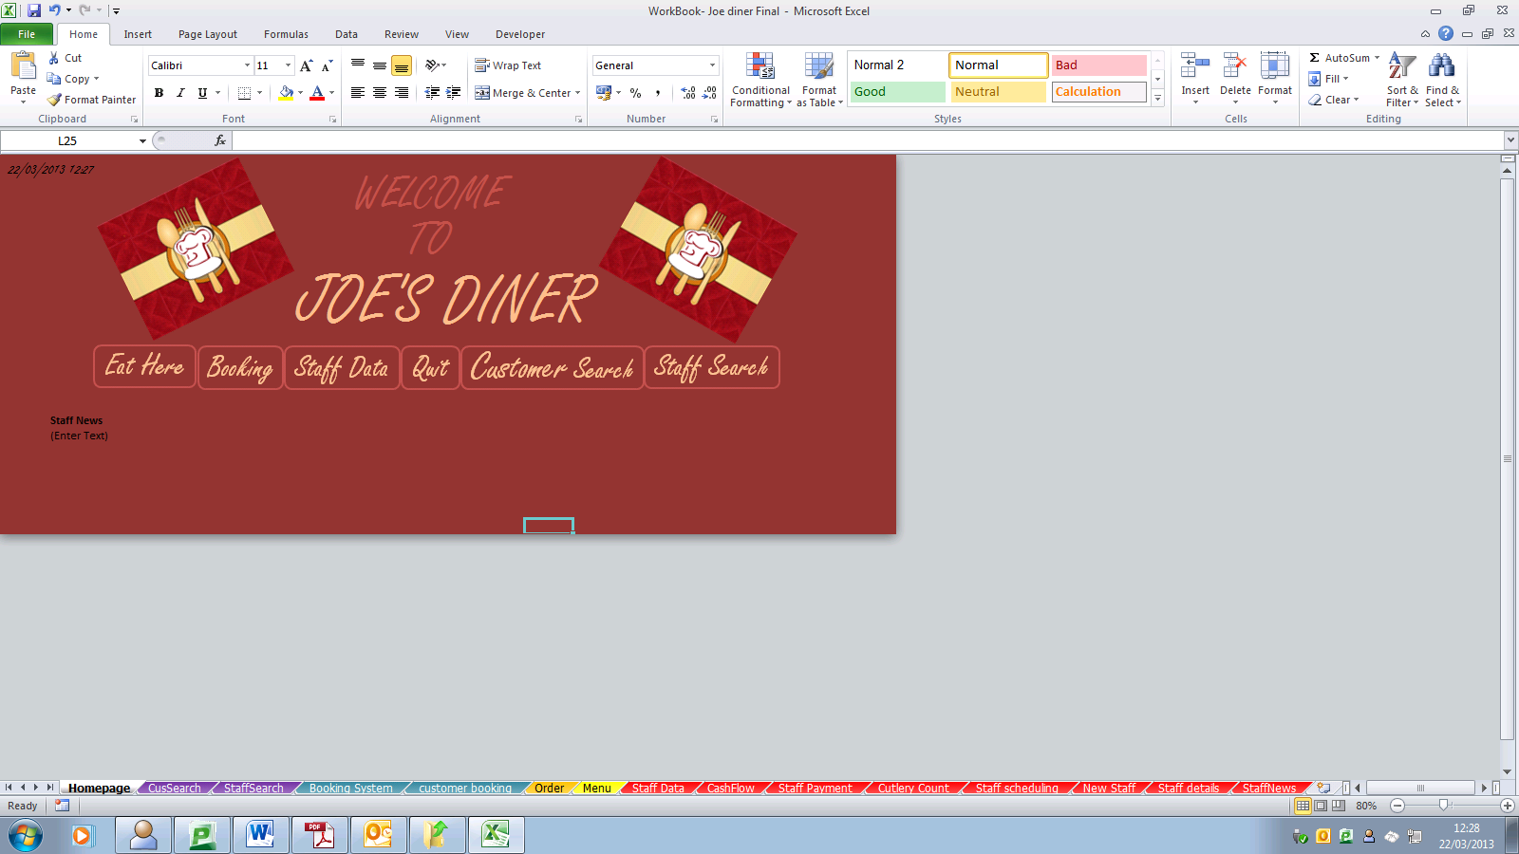

* Eat Here – Where you can order the food and can print out the payment
* Booking – Where you can reserved a table for a customer
* Staff Data – Where only the manager can click on this. Takes you to a different menu with all the staff details
* Quit – When you click on it saves and quit. This is the only way to exit the spreadsheet
* Customer Search – The menu where you can search the customer’s booking by their name
* Staff – Where you can search the staff’s details
*  This takes you back to main page (homepage)
*  This takes you back to the Staff Data menu page

**WorkSheets**

The worksheets

**Eat Here**

The order side shows what food you are going to order and all the food name will be here by clicking the drop list. It has all the starters, main, dessert and drinks.

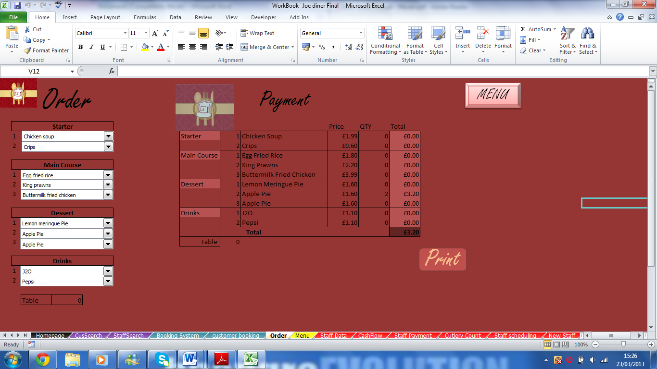

On the payment side it shows what you going to order and does change when choosing the food. The entire price has been link and it shows the total at the bottom.

This worksheet allows you to place an order for the customers. Also on this worksheet you can print out the receipt from what you ordered. This has been all linked up with choosing the meal, the total for each food and the total with whole. This also allows you to see the menu by clicking it on the right hand corner.

**Booking**

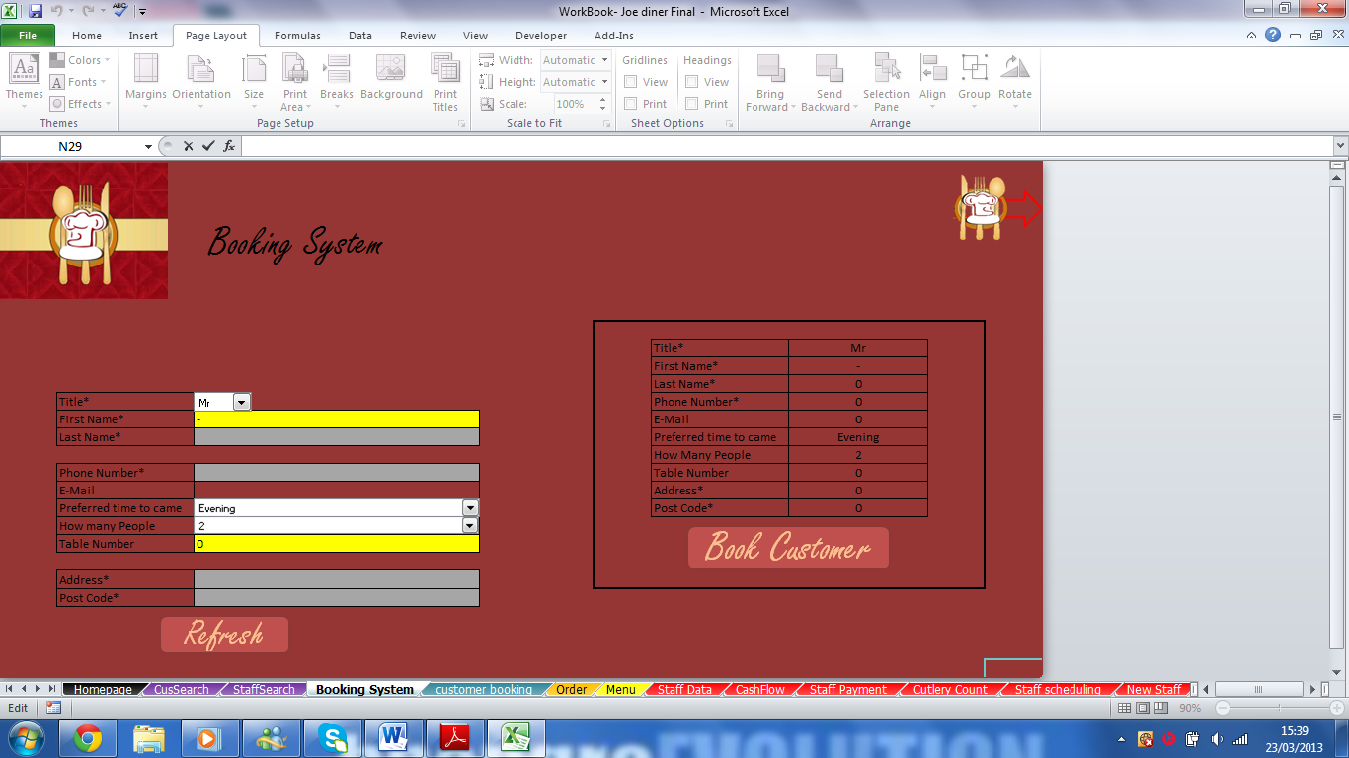

This worksheet will allow you to book and reserved a table for the customers. It will allows you to add their details from Title to Post code and with a click on the button it will take it to the Customers’ Booking page where it shows all the name which been saved.

Staff Date

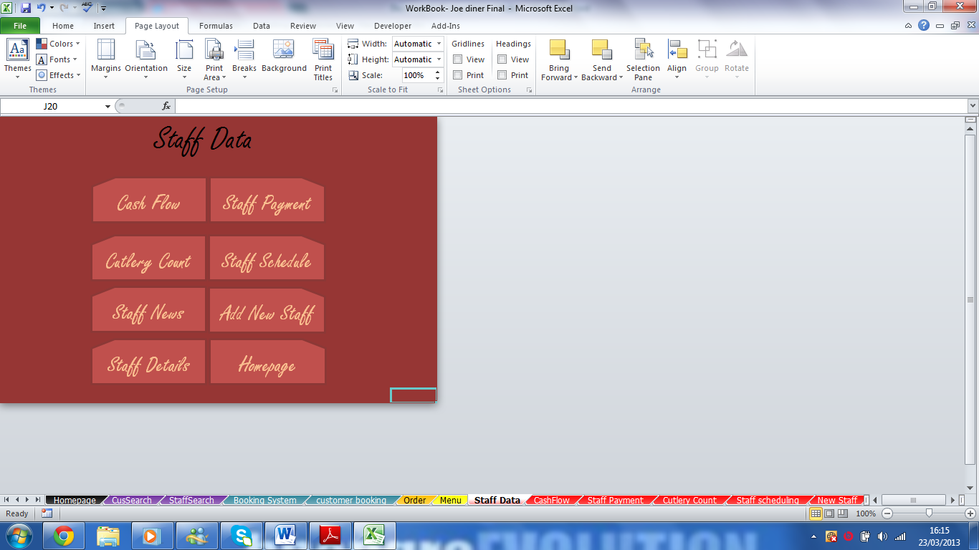

This is the menu page for seeing the progress of the company and the staff.

* Cash Flow – Profit and lost in the company
* Cutlery count – Shows how many are good and how many are needed
* Staff News - Updating the news to for the staff
* Staff details – Shows all the staff’s details such as name, job role and address
* Staff Payment – Shows how much the staff are earning and seeing how many days they taken off
* Staff Schedule – Shows the staff what their job is in that hour
* Add New Staff – This is where you can add new staff
* Homepage – This takes you back to the main page.

Cash Flow

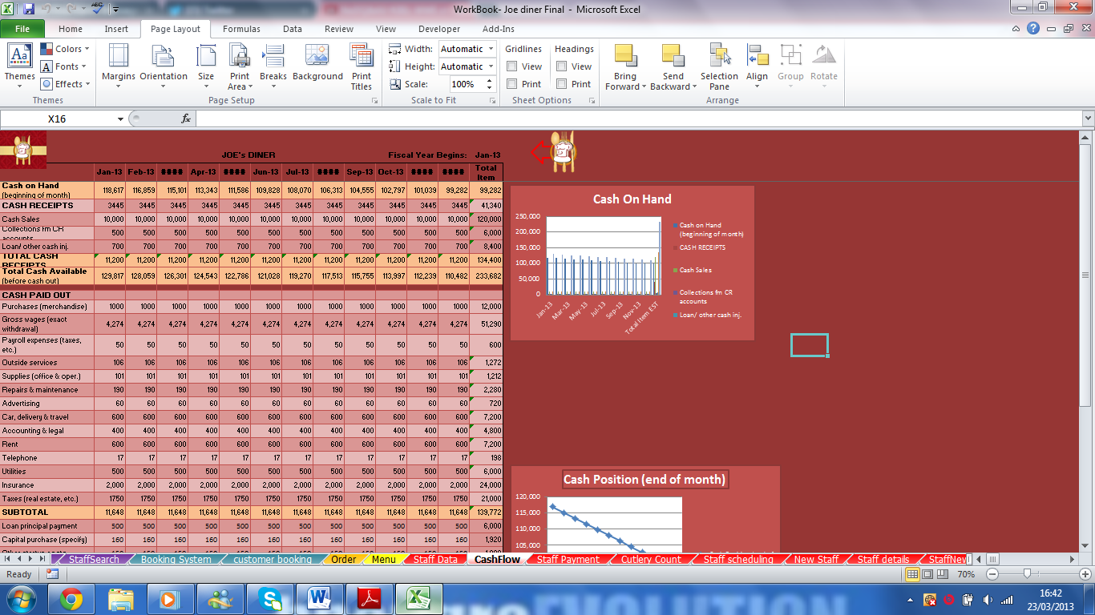

This is slipped up in three sections. Cash on Hand where it shows how much you have started and must is given in each month. The cash been paid out such us on delivery and taxes and the subtotal. There are two graphs which changes when you enter the numbers so there is no need to make one every time.

Cutlery Count

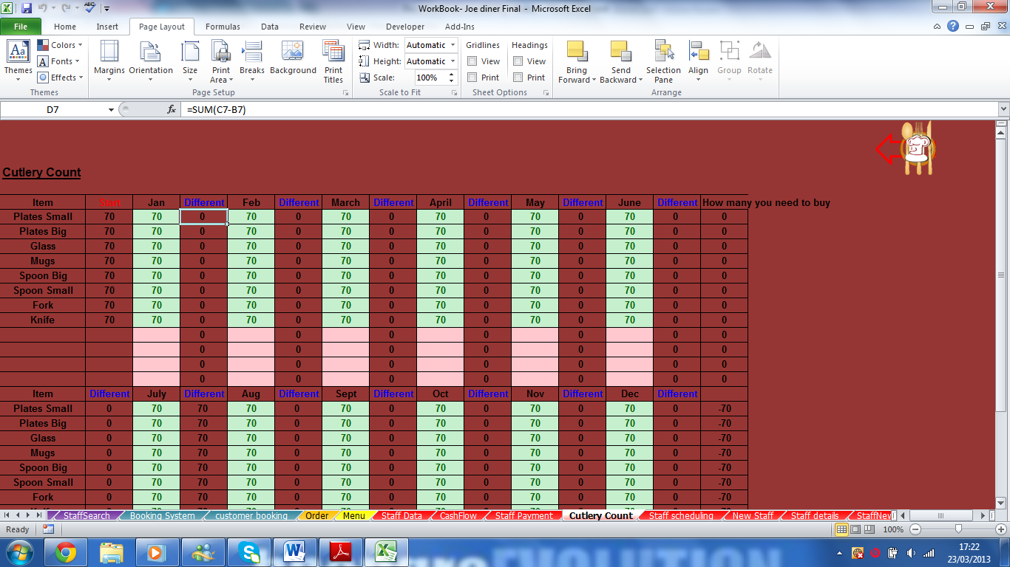

This is shows many cutleries are still good to be used and each month you need to enter how many is still good to use. The conational formatting will help you when you need to buy new ones when it goes Red. This is where you can add more cutleries under items when needed.

Staff News

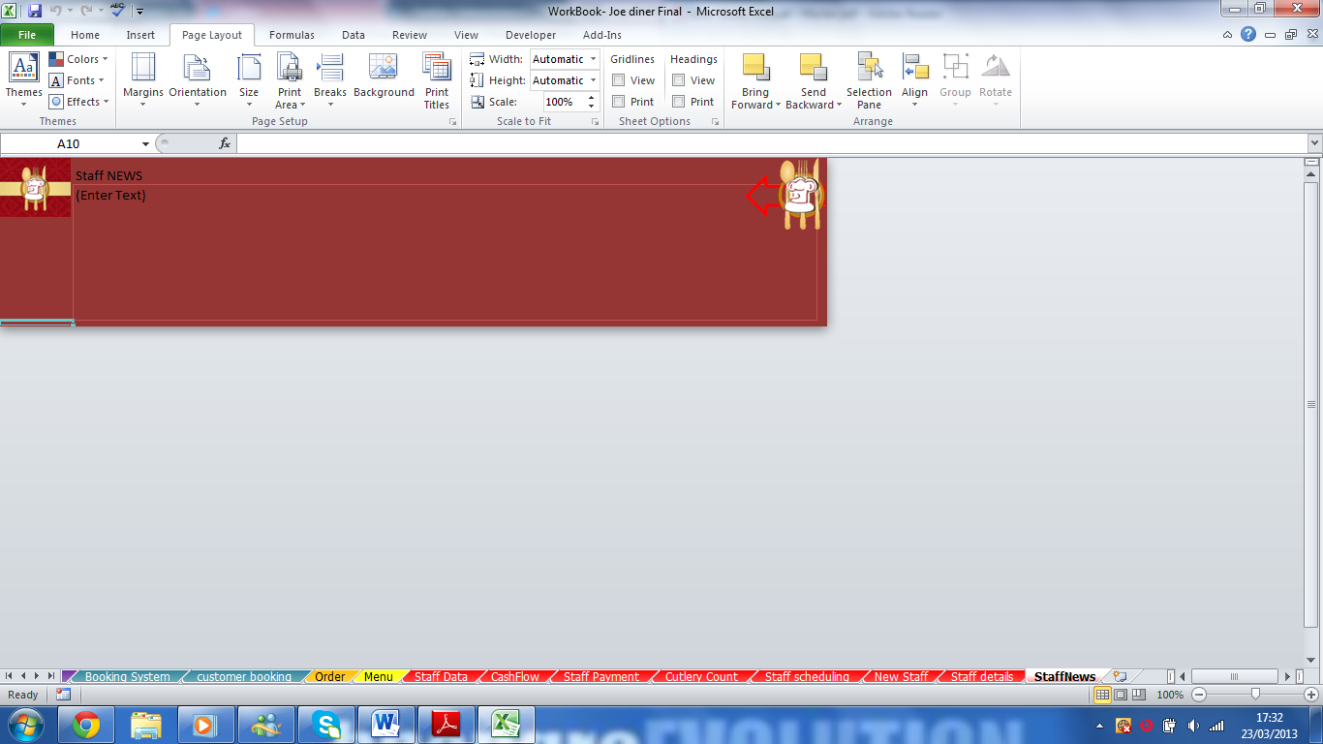

Can add any text and any staff can read it on the main page. This is for saying if you have any meetings or want to give everyone updates for today.

Staff Details

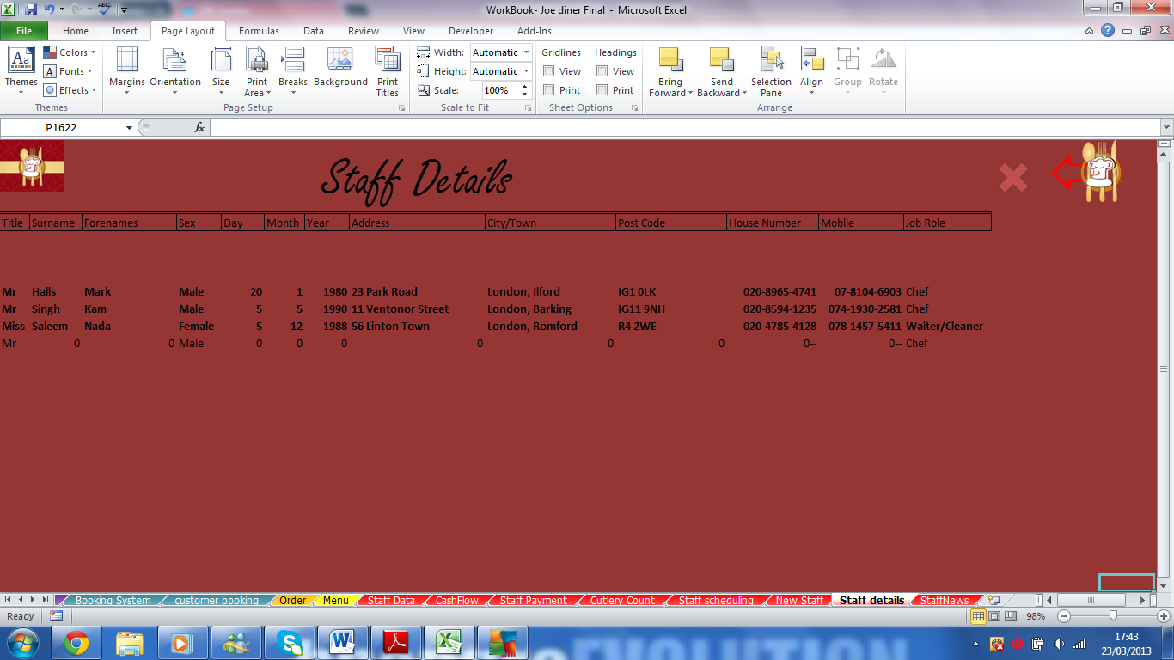

This is where it shows all the staff details. This can been looked over and over again because it has been saved. This can be access whenever for the manager because you need the password. This worksheet you don’t need to change it around however if you need an update on the staff details. On top there is the homepage button, a cross to delete the staff’s details and the button back to the staff data menu page.

Staff Payment

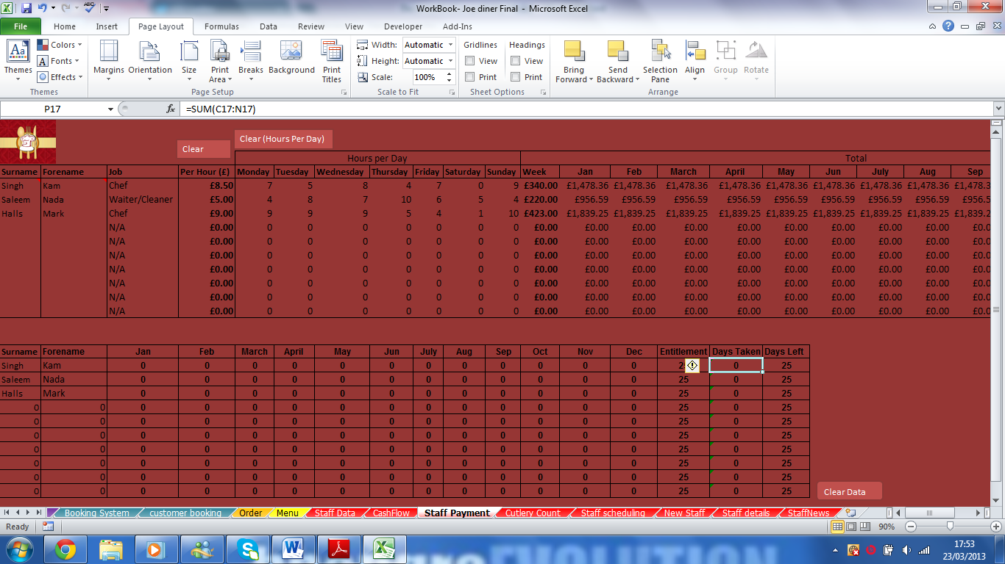

This worksheets allow you to enter how many hours the staff can do with this it will enter how many hours they get paid in weeks, month and in a year. You need to enter the names of the staff, their surname and forename are required. Their names also show below on the “Days off” table which makes it easier. The table shows all the month and it should be filled every month as their have certain days off in the whole year. As the manager you have call the control to choose how many days they can be taken off.

Staff scheduling

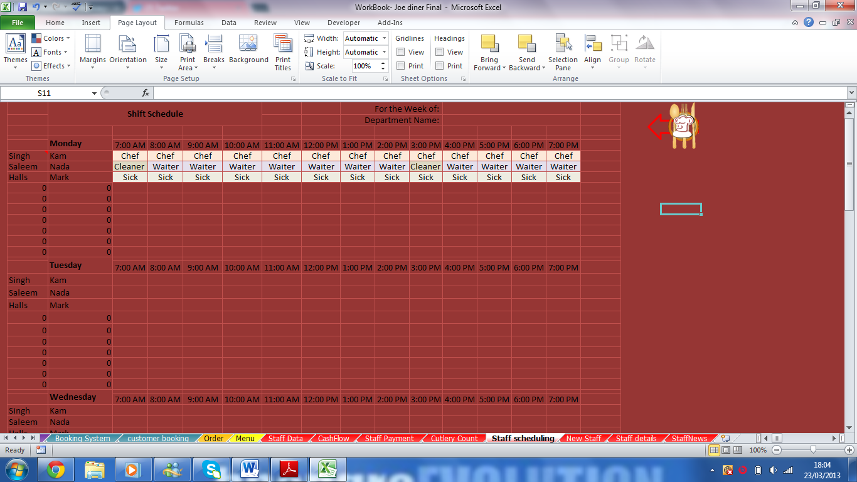

This should be updating every week where it shows what each staff are doing in each hour. You can control where you can choose as it has a drop down list

Add new staff

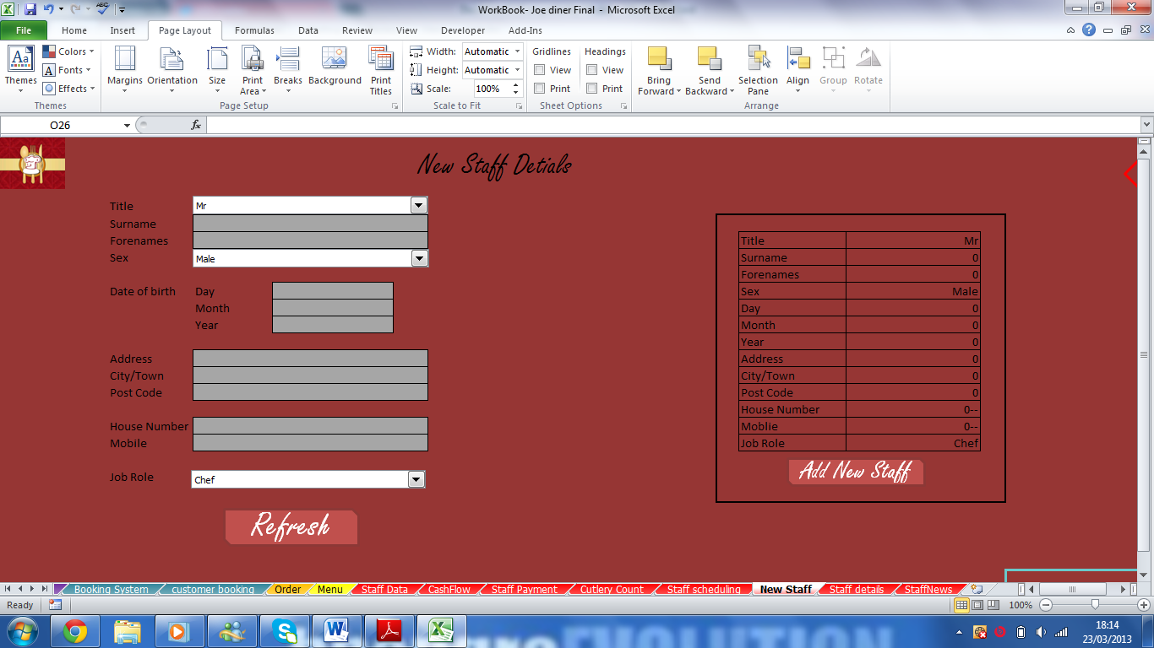

Same as the customer booking this is where you can enter a new staff. Enter where the grey cells are and then press Add new staff and it will save it in the back office

Data Input

There are data input but two of them are entering a booking and staff details.

**Customers’ Booking**

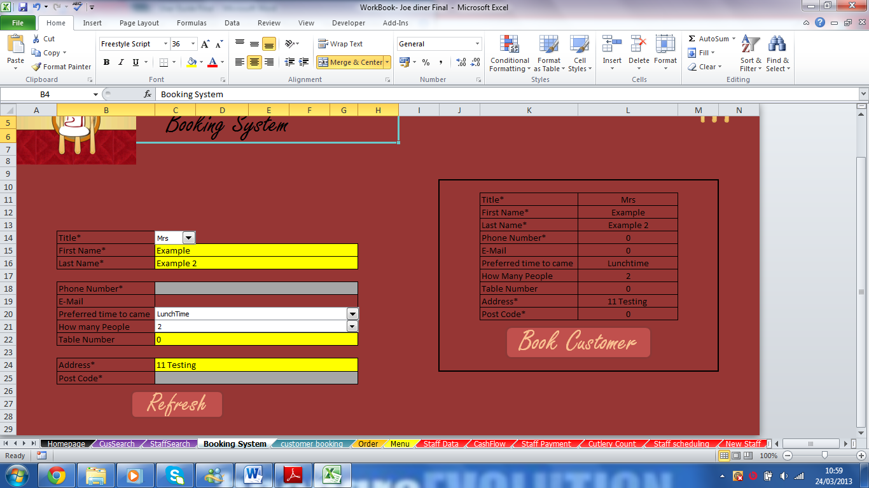

First by entering the names it will turn yellow so it shows data has been entered. You don’t need all their details however it is good when you want to send letters to them.

You can clear all the data by clicking refresh.



All the information copied and it shows what you typed. When you’re happy book the customer details and transfer to a back sheet which saves all the customers’ booking.

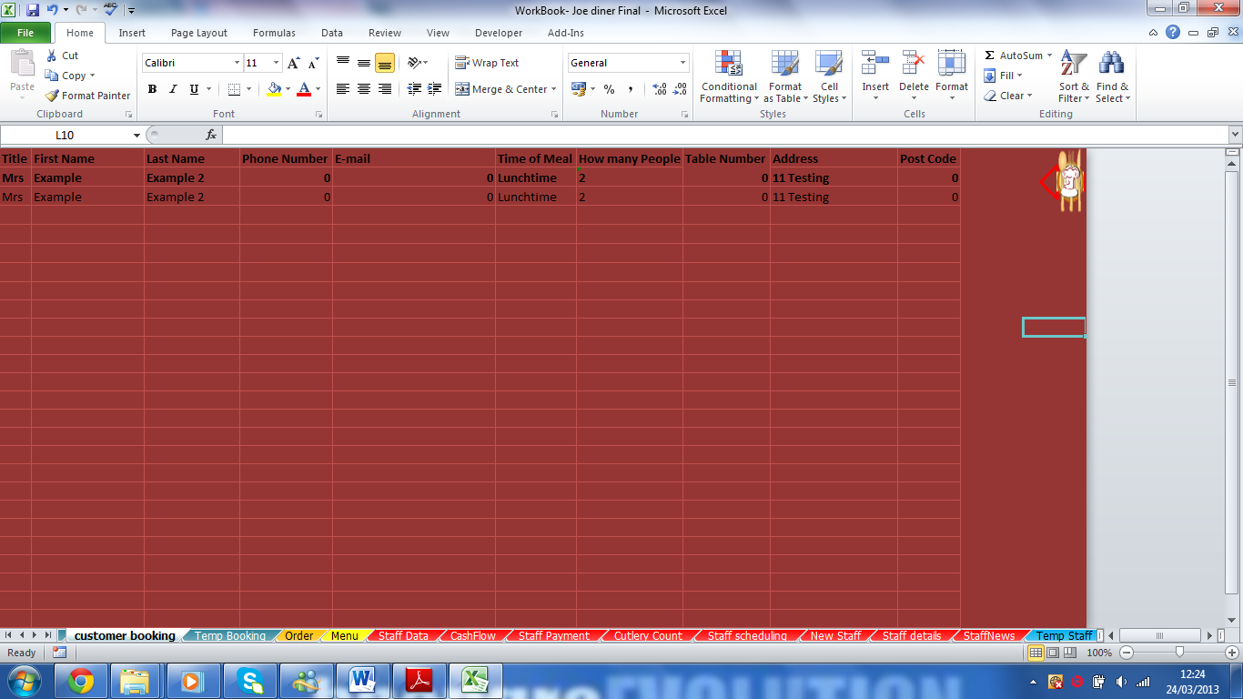

After clicking the booking customers it takes you to this sheet and it saves the booking. So you will be able to look at whenever.

This is also the same for adding a new staff. By entering data for the staff however you need to enter all their details because it is company policy. After it has been checked, click on the add staff and it will go to the database so you can see all the staff details.

Data Outputs

Viewing charts

Charts can be easy access by going on the Chas flow Worksheet.

This is one of the charts for the cash flow. It shows how much money you get per month and see how it is growing. This changes automatically when entering numbers.

This is another chart which shows the increase and decrease of the cash position at each end month

Miscellaneous

Troubleshooting

Most of the time it won’t work is that you typed in the wrong text in the data entry. However some do occur a lot.

On the Main page, the Staff Data will not work because you need the password to access it.

Without Password

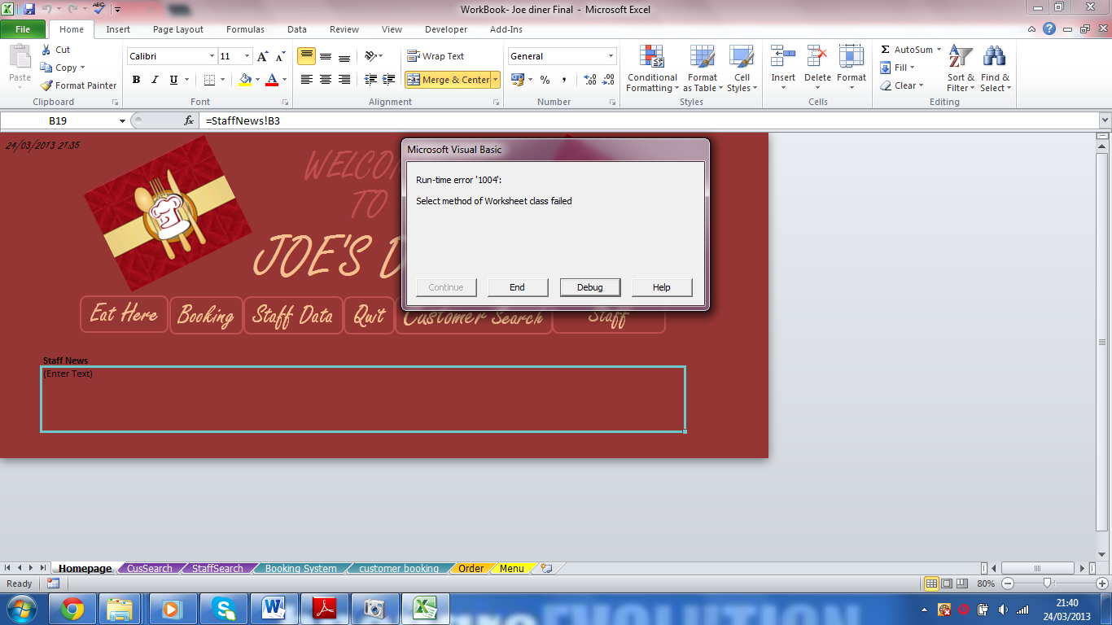

To enter with a password, you need to renter the workbook by clicking on the “Quit” button.

With Password

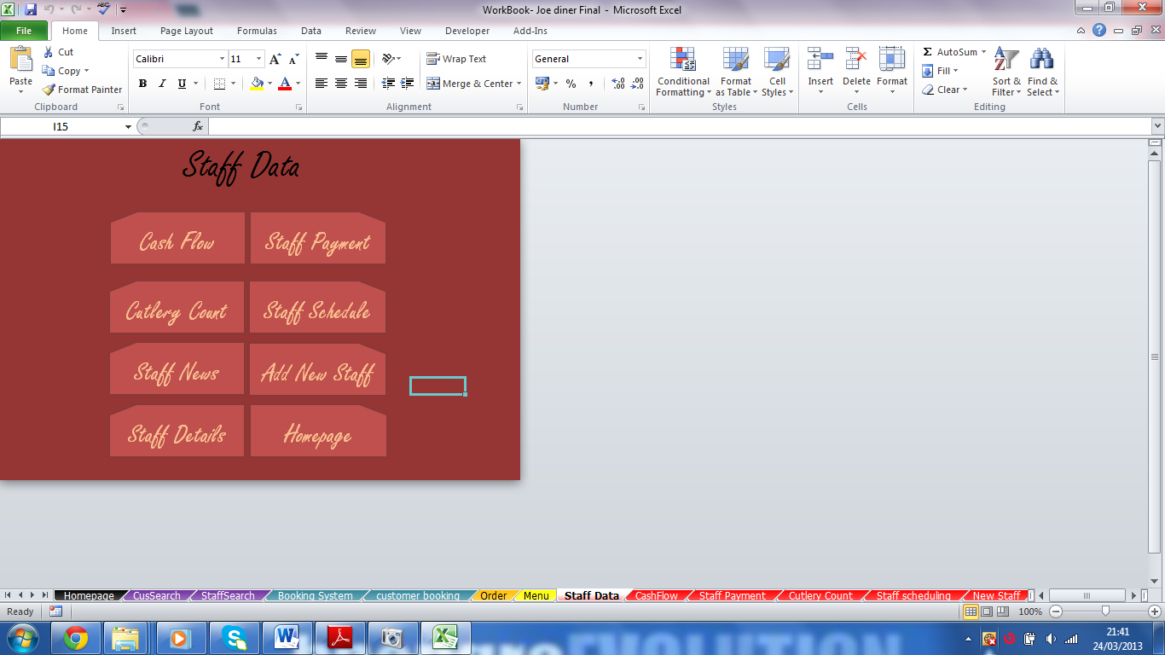

Also you all the spreadsheet on unhide because without it the Marco wouldn’t work as it will say you need to “bug” the script however this is no need because there is no Marco will work if the worksheet are in hide.

Exiting the Workbook.

To exit the workbook, you need to go to the main menu (Homepage worksheet) and click “Quit” It will say you want to save it; it should be yes because this is the only time you can save the work.

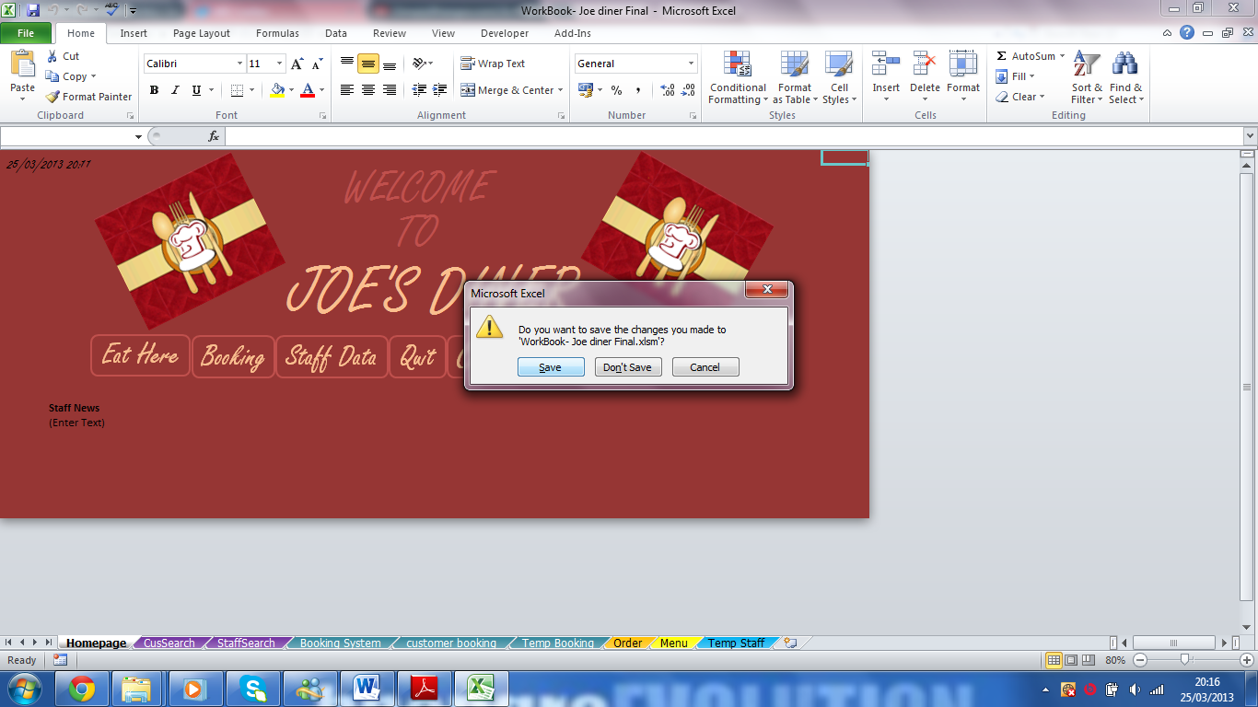

Deleting the Workbook

To uninstall or delete the workbook for any problem first it should be wise to exit the workbook because it won’t work. Find the workbook in the folders and delete it by, right click and delete.

